For Immediate Release
Contact: Yati Riskey
Faben2000@yahoo.com
720-229-3821

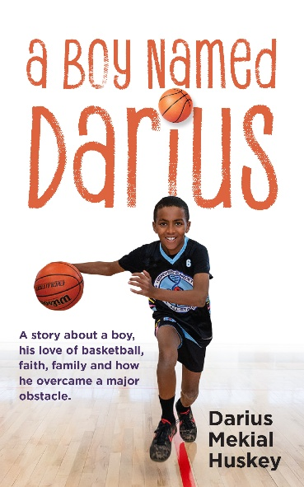

10-year-old Coloradan Beat the Odds

January 27, 2025, Denver, Colorado. Darius Mekial Huskey had a dream. One that started before he was four. He is a student at the Buffalo Trail Elementary School in the fifth grade and the author of A Boy Named Darius.

- Since he was four, he wanted to play basketball … to become an NBA player.
- Since he was four, he has watched basketball on TV when he was at home.
- Since he was four, he has memorized the plays and moves of great players.
That came to a halt when a bump on his head was diagnosed as a rare autoimmune disease when he was seven. A bump on his head revealed he had a rare disorder called Langerhans Cell Histiocytosis. His body was making too many of the white blood cells that impacted his immune system. One out of 200,000 children are impacted a year.
LCH could easily destroy his dreams … and him if it wasn’t immediately treated.
A Boy Named Darius started as a journal. “I was angry and the journal was the way I could express my feelings.” At ten, he turned his journal into a published book, calling it A Boy Named Darius.
This is Darius’ story, day by day and what he did so he could start living his dream again. It is a story about a boy, his love of basketball, faith, family, and how the boy overcame a major obstacle. Basketball became his medicine.
His ideal day usually starts after school when he heads to basketball practice and his weekend games that are set up with the Amateur Athletic Union (AAU) program for youth.
Darius will be signing books on Saturday afternoon, March 15 at Barnes & Noble, 960 S Colorado Blvd in Glendale and Sunday afternoon, April 6 Barnes & Noble, Southlands Mall in Aurora.
Press inquiries:
Darius Huskey is available for interviews when he’s not in the classroom or on the basketball court. Appointments can be made through Yati Riskey at 720-229-3821 and Faben2000@yahoo.com.

